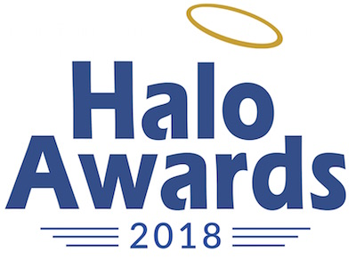

Entry Form

March 23, 2018 – Regular Deadline (application fee waived)
March 30, 2018 – Late Deadline (with $50 application fee)
Entries are to be sent to: Nudge@engageforgood.com

To Enter:
- Read this application in its entirety.
- Pay entry fee online (if after March 23, 2018).

- Submit this completed application to Nudge@engageforgood.com

Please reach out to nudge@engageforgood.com with any questions you may have.
Find inspiration and direction at http://www.nudgingforgood.com/category/case-study/

The “Nudging for Good” Awards were originally launched in
Europe by AIM (www.aim.be), who supports the initiative.

Your Preliminary Information

COMPANY:
BRAND:
INITIATIVE:

Primary Contact
First Name:
Last Name:
Email address:
Phone number:

Alternate Contact
First Name:
Last Name:
Email address:
Phone number:

NONPROFIT (if involved):

What was the desired behavioral change?
What is the current behavior which the Nudge sought to change – or what new behavior was encouraged?
…

What were the barriers to change that had to be overcome?
…

How is this behavioral change positive for individuals and/or important for society?
…

How was Nudge applied?
Describe the Nudge that was created, how it was implemented – and how it leveraged Behavioral Economics principles to address the challenge.
…

Illustrating the Nudge Concept

[Insert video link/url to illustrate the Nudge]

Find inspiration and direction at http://www.nudgingforgood.com/category/case-study/

To document your entry, please submit no more than six pages of print, radio or video creative, website, packaging, photographs of events or displays, premiums, research, clippings and other documentation of program impact. Photographs or renderings of oversized materials are preferable to the actual items due to limited storage. Please submit online links to videos or video files in any format except .wmv.
Please contact nudge@engageforgood.com on how to properly submit via mail.

What were the outcomes?
Please share evidence of the positive impact of the Nudge on the consumer behavior.

This section is strongest when it includes specific figures (ex. “Water consumption in tested households decreased by 35 %”) gathered from in-market data (preferable) or market research studies/tests.

Find inspiration and direction at http://www.nudgingforgood.com/lesson/5-evaluate/

